**Installing and Configuring Oracle GoldenGate Veridata 12c (Server and Agent)**

**Steps**

* Install Veridata Server
* Create the GoldenGate Veridata Repository Schema using RCU
* Configure WebLogic domain for Oracle GoldenGate Veridata
* Start Admin and Managed Servers
* Create the VERIDATA_ADMIN user
* Launch and test Veridata Web User Interface
* Install the Veridata Agent on hosts which you want to run Veridata comparison jobs
* Configure and start the Veridata agent

Download **V44427-01.zip** Oracle Fusion Middleware 12c (12.1.3.0.0) GoldenGate Monitor and Veridata

[oracle@pl-p1-mgmt-con-01 FMW12c]$ **unzip V44427-01.zip**

Archive: V44427-01.zip

inflating: fmw_12.1.3.0.0_ogg.jar

[oracle@pl-p1-mgmt-con-01 FMW12c]$ **java -Djava.io.tmpdir=/home/oracle -jar fmw_12.1.3.0.0_ogg.jar**

Launcher log file is /home/oracle/OraInstall2015-09-06_05-12-17PM/launcher2015-09-06_05-12-17PM.log.

Extracting files.....

Starting Oracle Universal Installer

Checking if CPU speed is above 300 MHz. Actual 1200.000 MHz Passed

Checking monitor: must be configured to display at least 256 colors. Actual 16777216 Passed

Checking swap space: must be greater than 512 MB. Actual 33554428 MB Passed

Checking if this platform requires a 64-bit JVM. Actual 64 Passed (64-bit not required)

Checking temp space: must be greater than 300 MB. Actual 14738 MB Passed

Preparing to launch the Oracle Universal Installer from /home/oracle/OraInstall2015-09-06_05-12-17PM

Log: /home/oracle/OraInstall2015-09-06_05-12-17PM/install2015-09-06_05-12-17PM.log

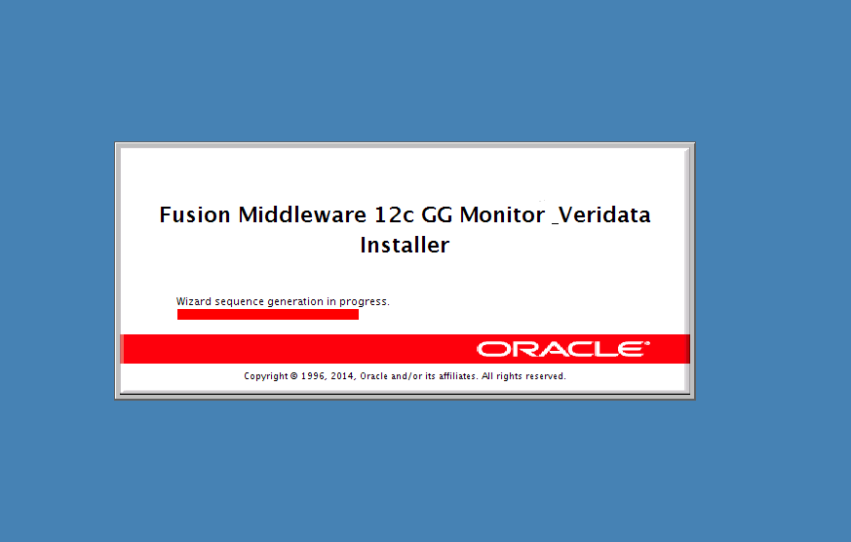

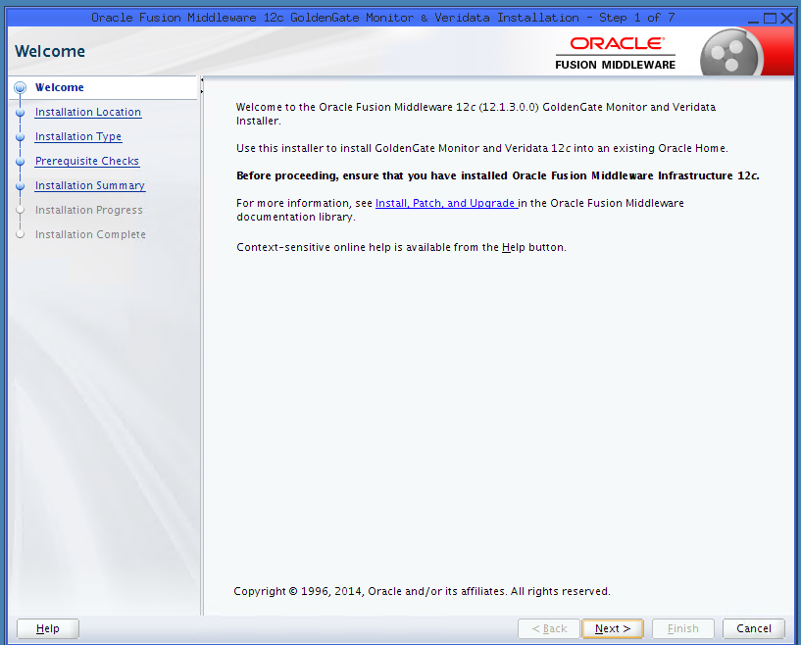

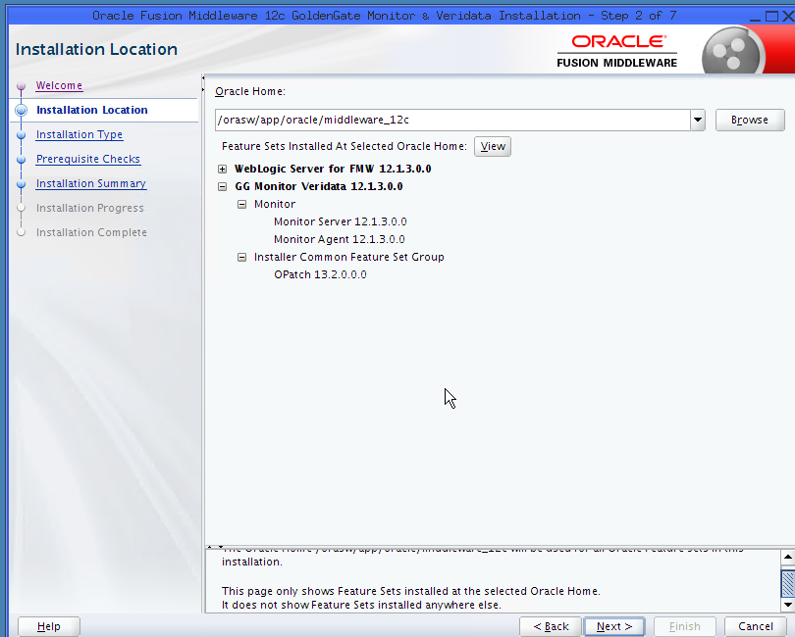

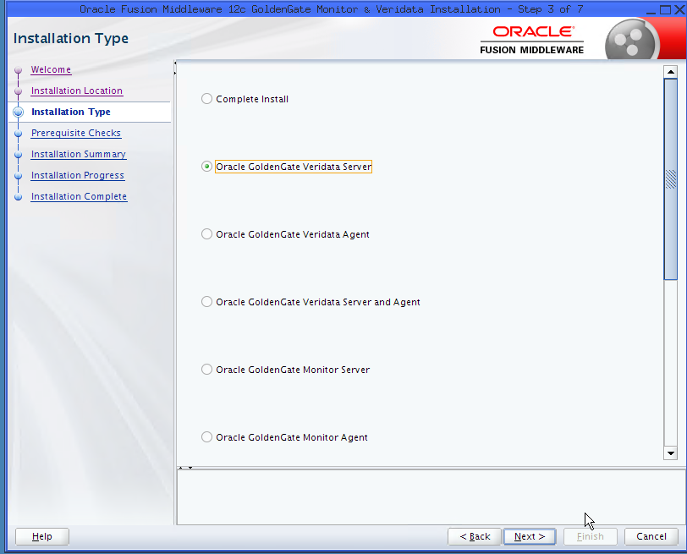

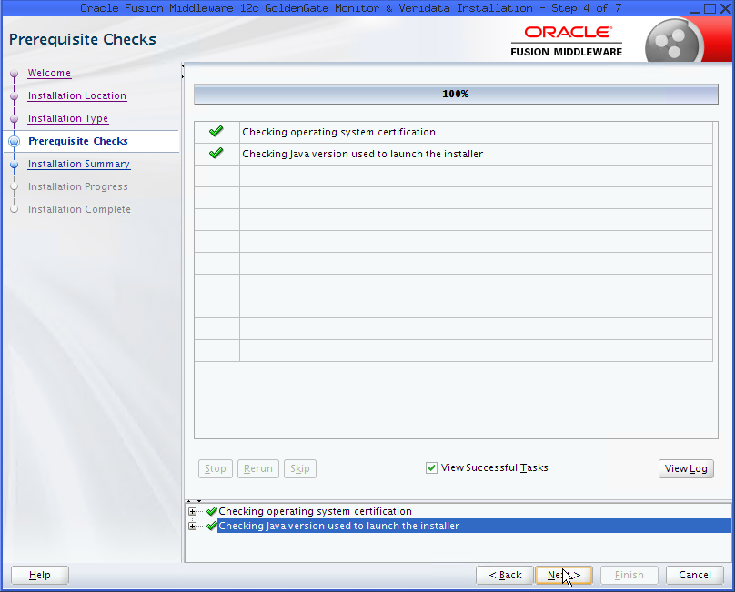

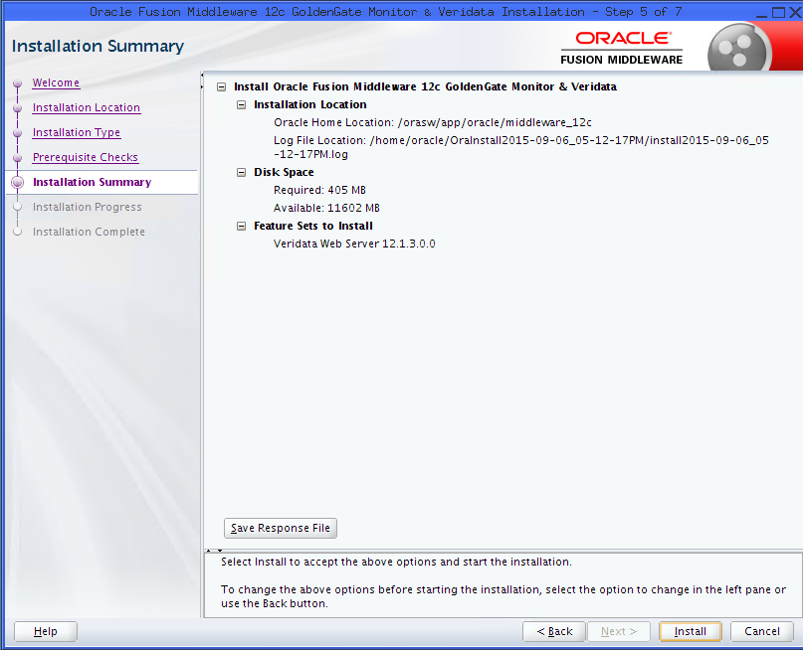

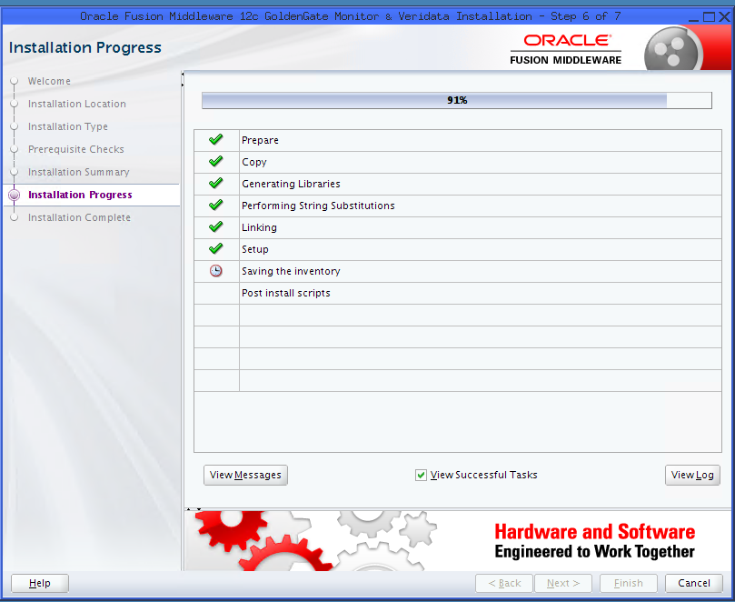

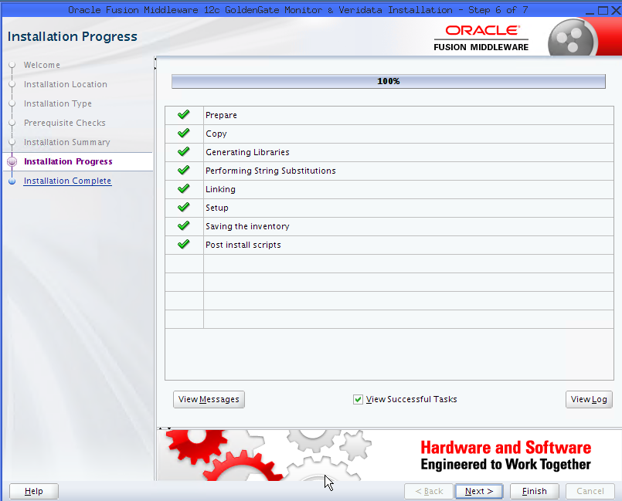

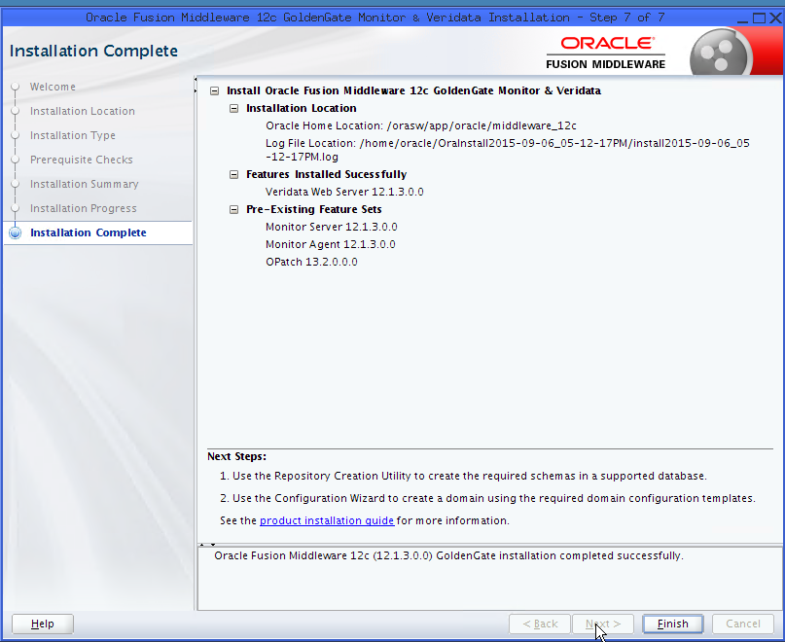

**Create the GoldenGate Veridata Repository Schema using RCU**

[oracle@pl-p1-mgmt-con-01 FMW12c]$ **cd /orasw/app/oracle/middleware_12c/oracle_common/bin**

[oracle@pl-p1-mgmt-con-01 bin]$ **./rcu**

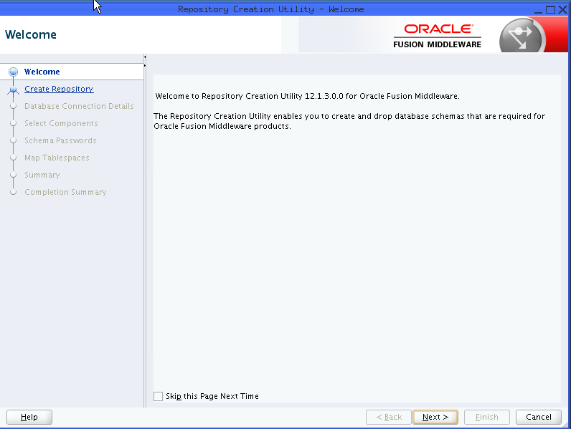

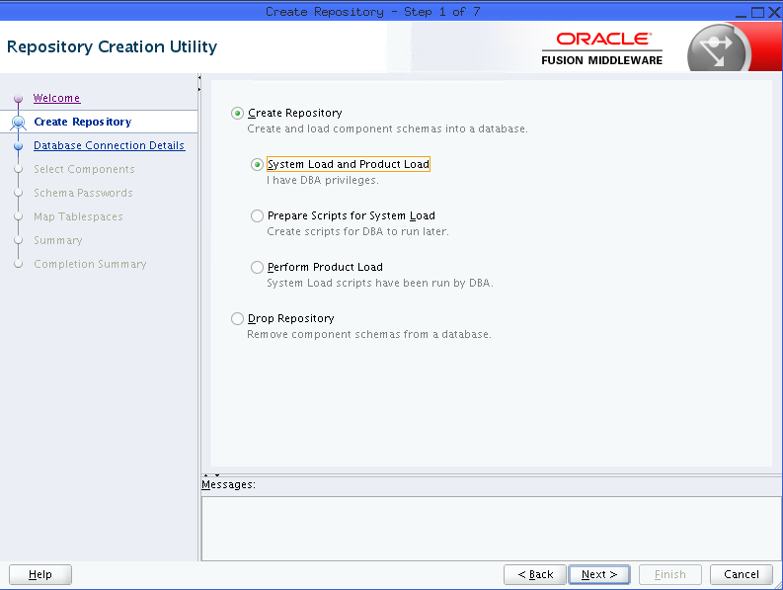

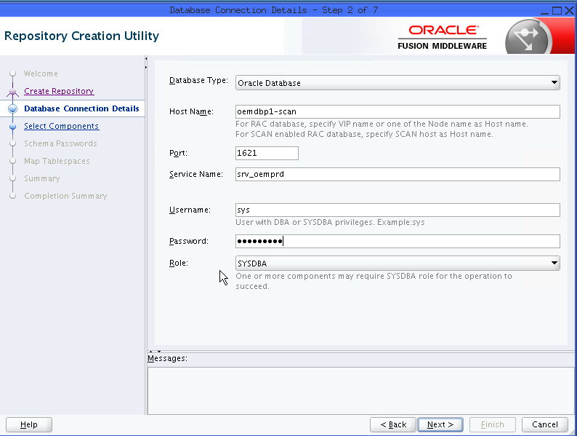

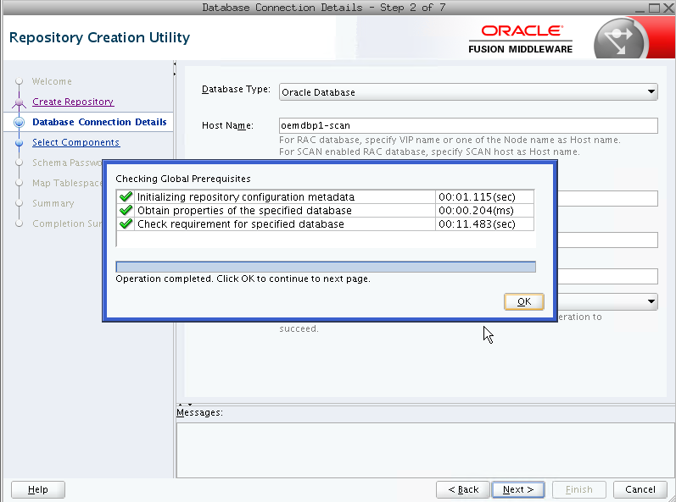

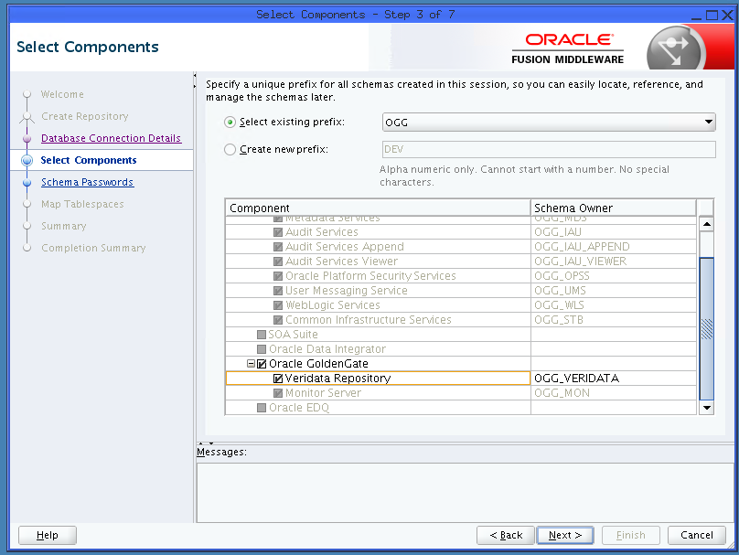

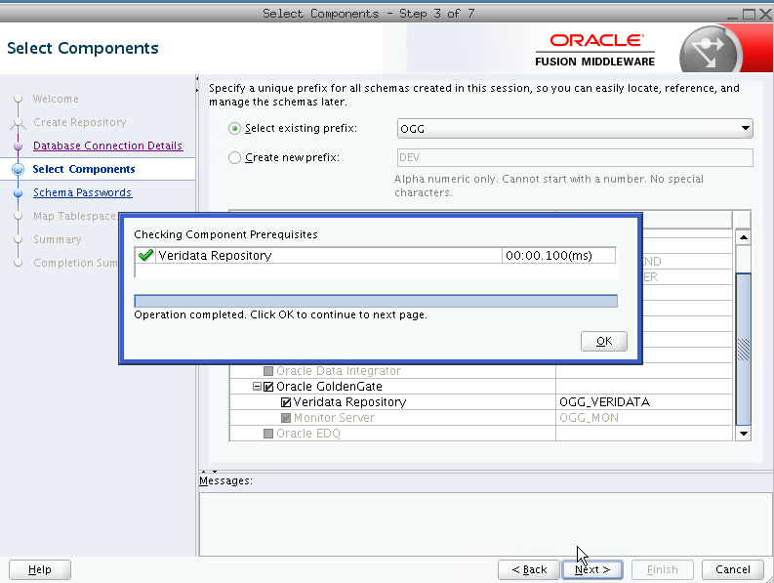

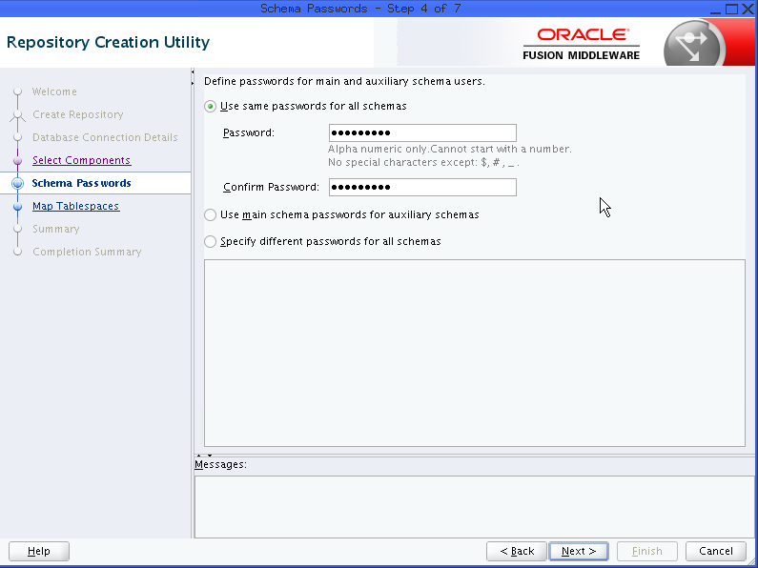

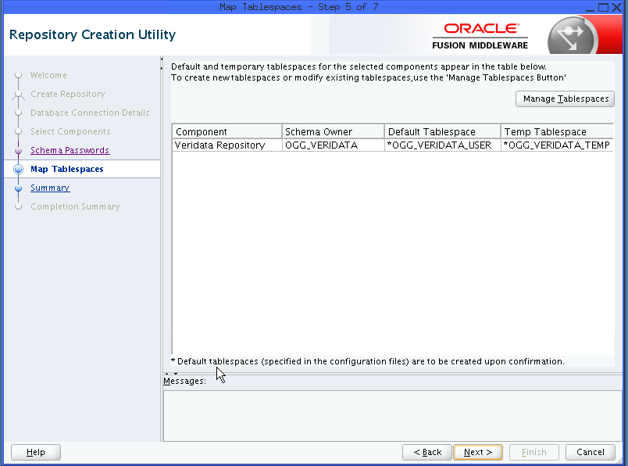

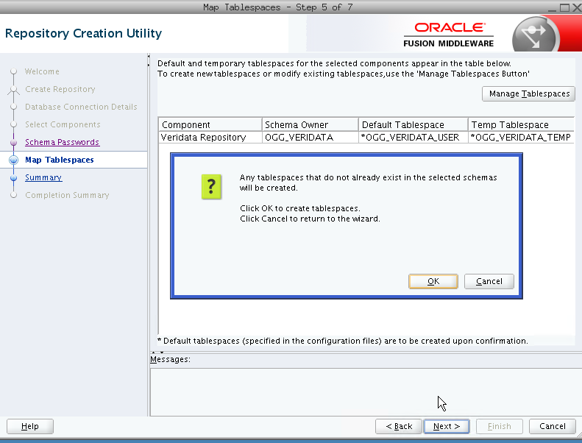

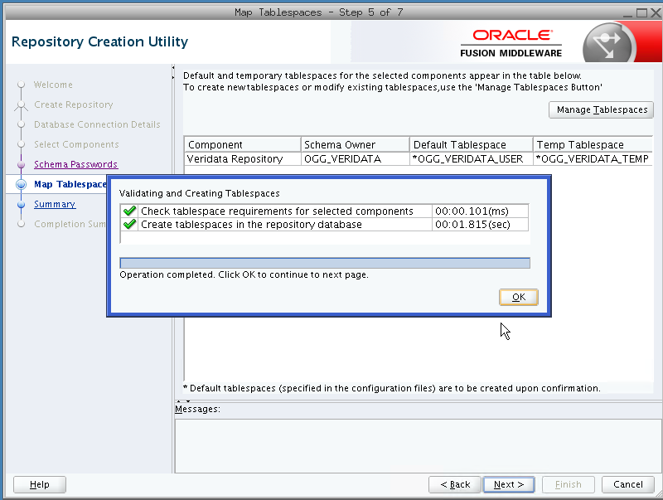

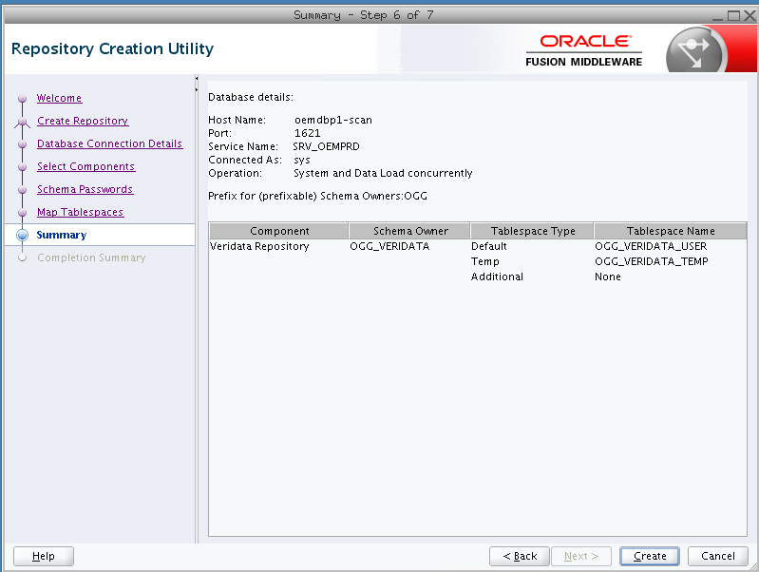

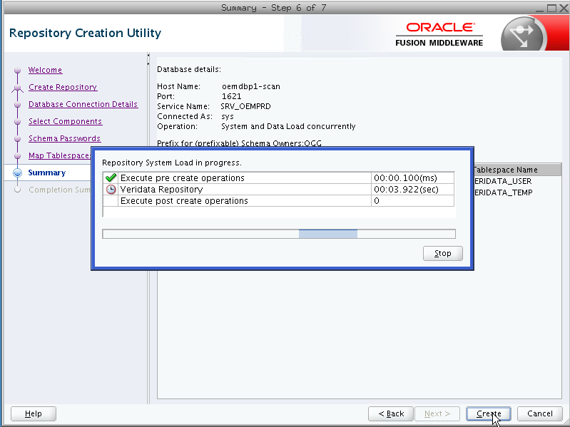

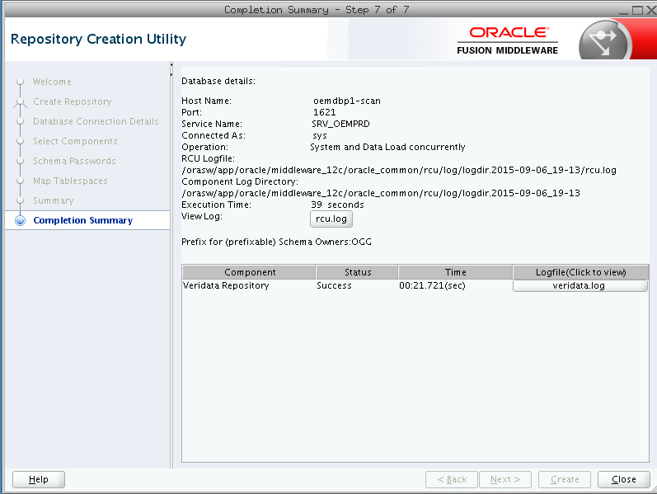

**Configuring Domain for Oracle GoldenGate Veridata**

[oracle@pl-p1-mgmt-con-01 bin]$ **pwd**

**/orasw/app/oracle/middleware_12c/oracle_common/common/bin**

[oracle@pl-p1-mgmt-con-01 bin]$ **./config.sh**

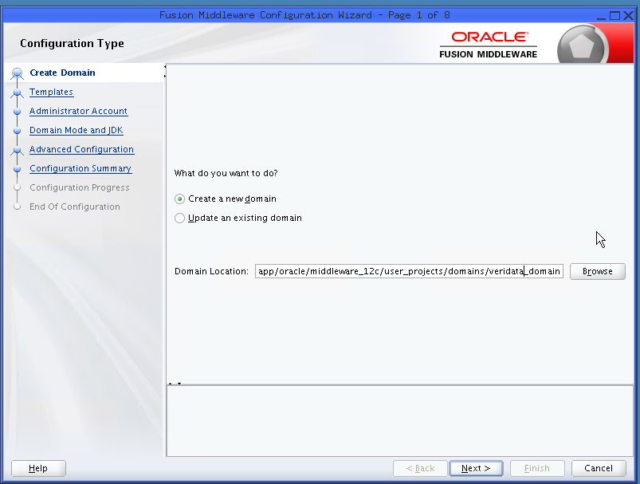

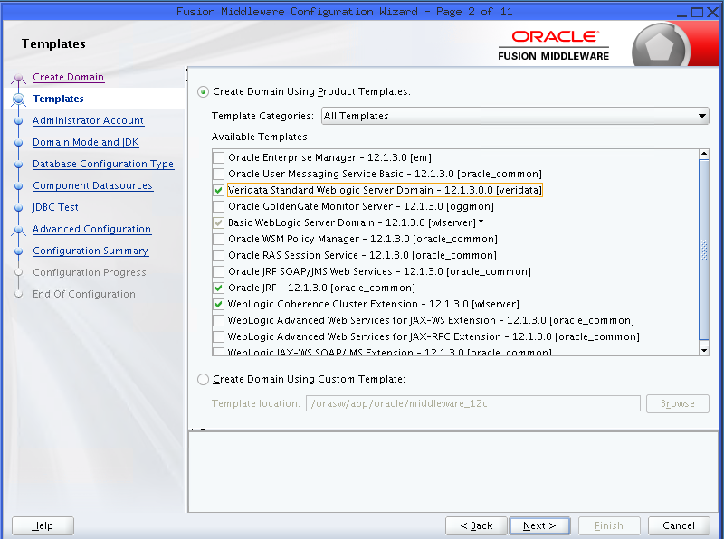

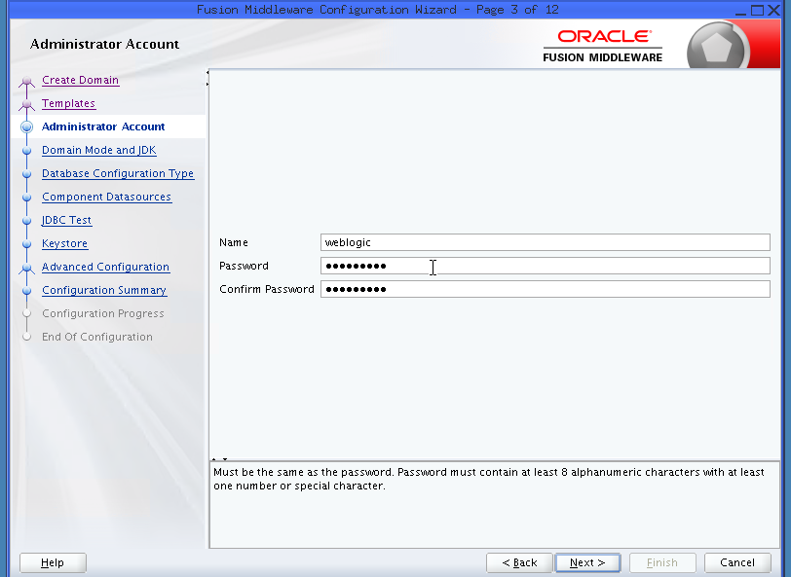

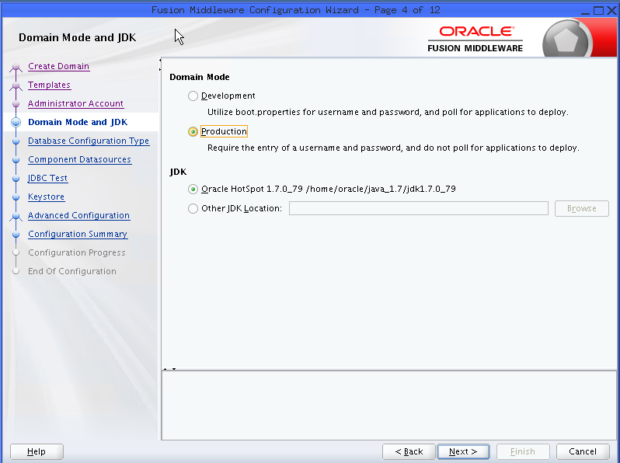

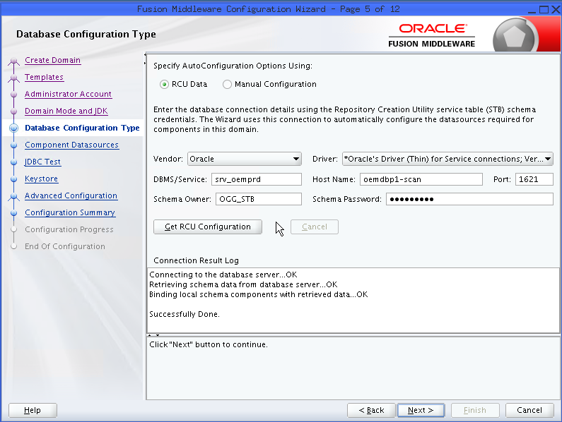

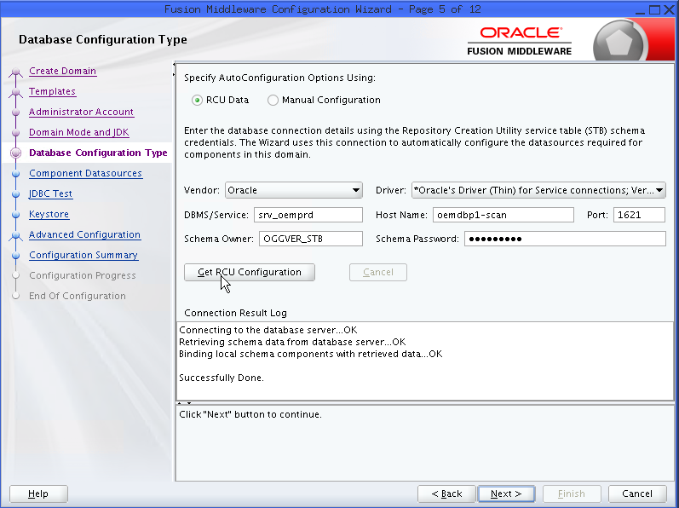

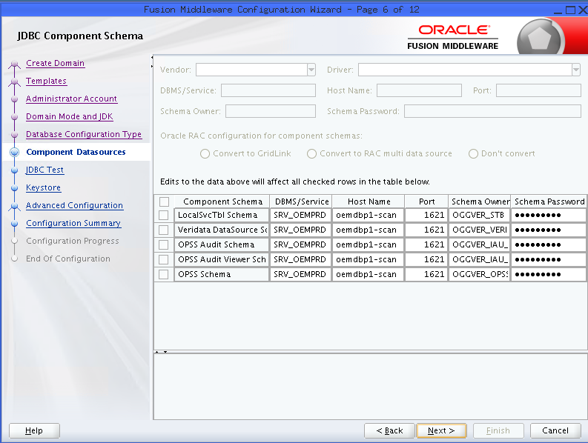

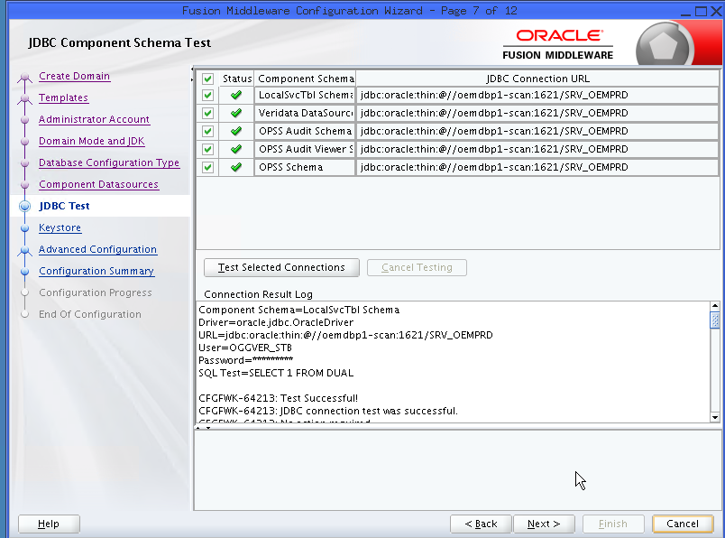

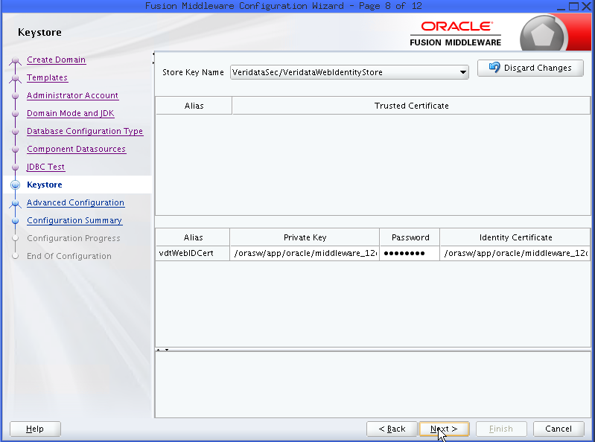

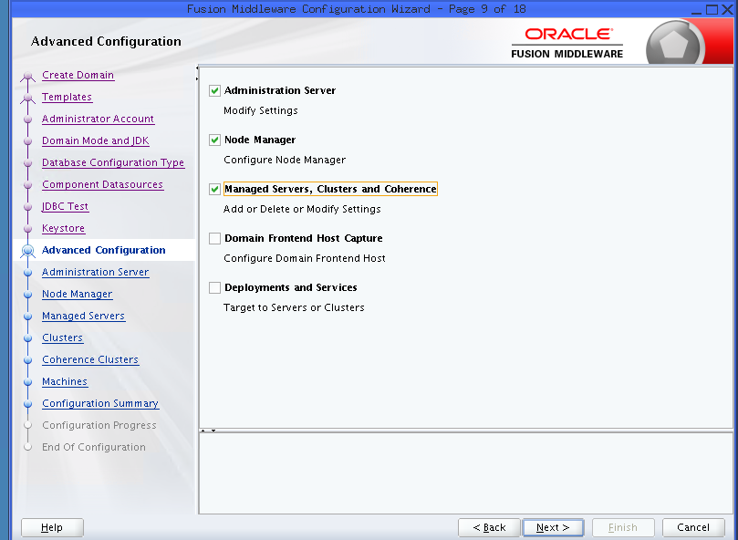

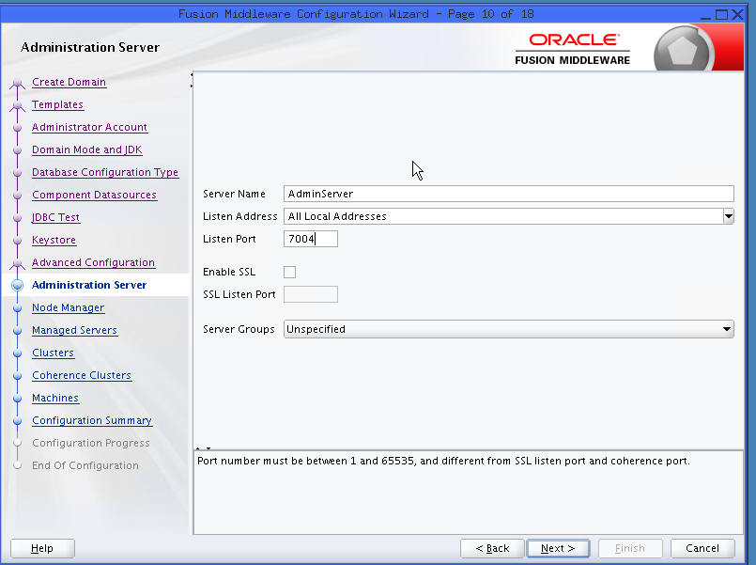

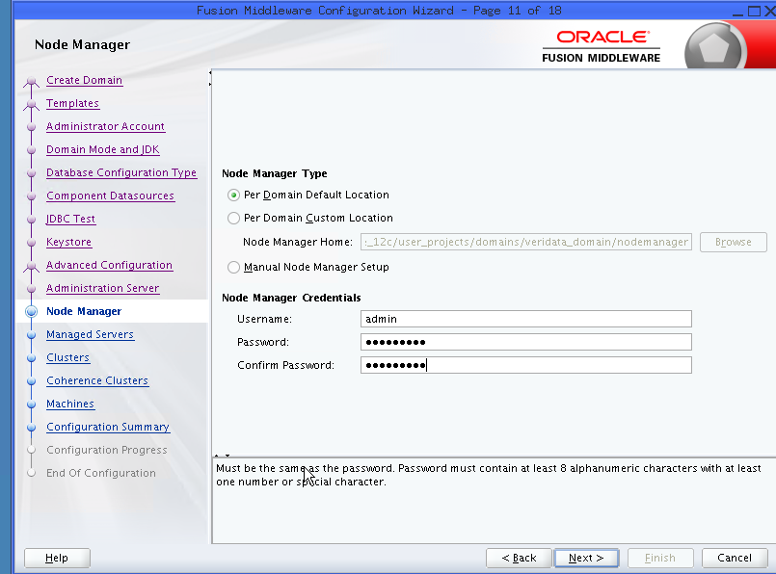

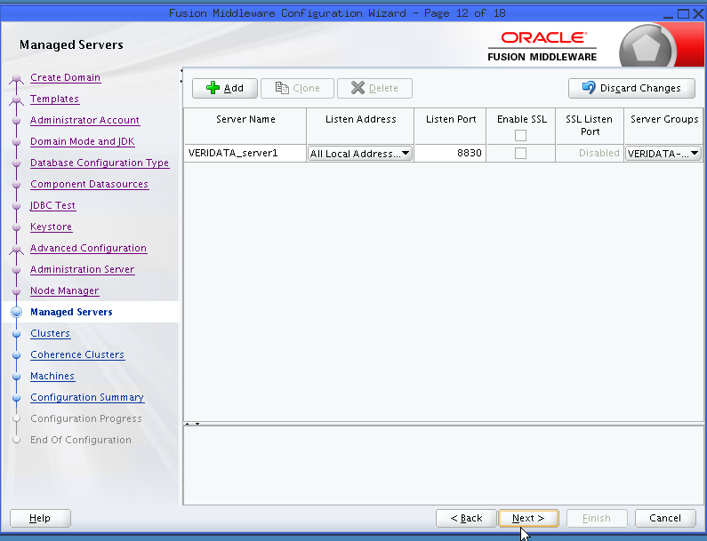

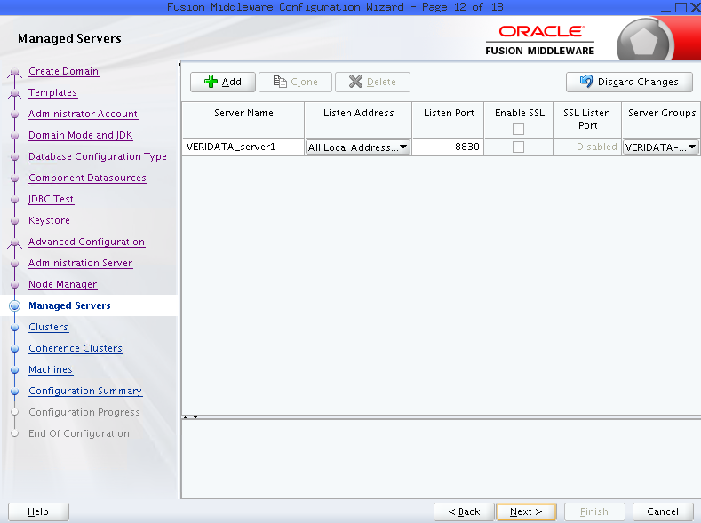

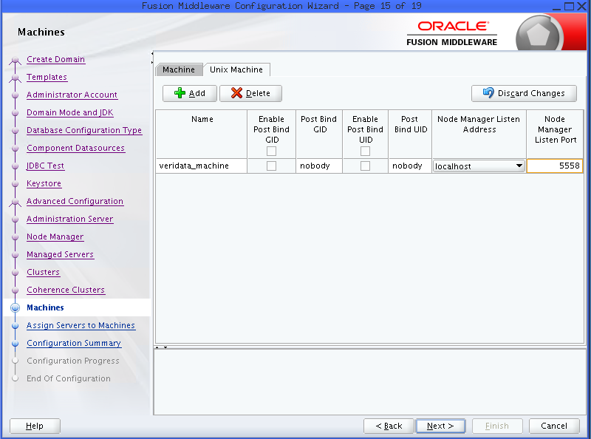

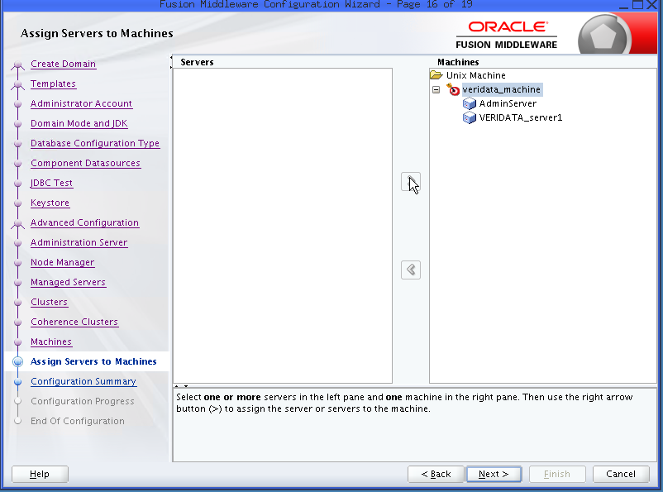

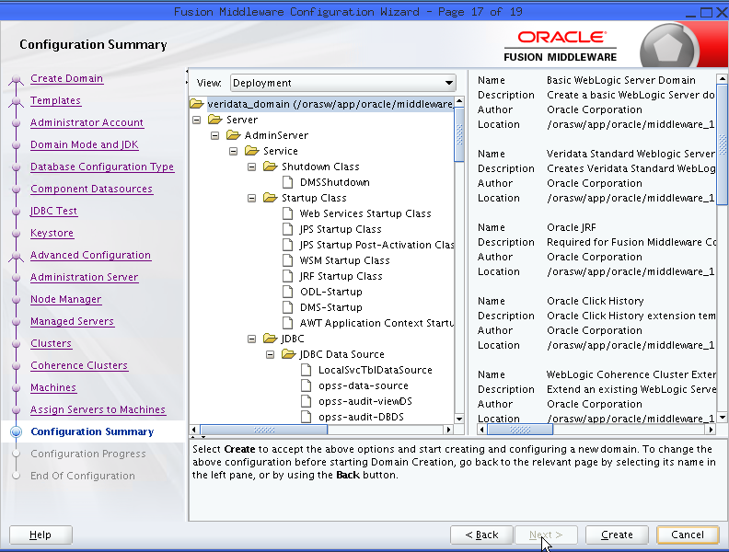

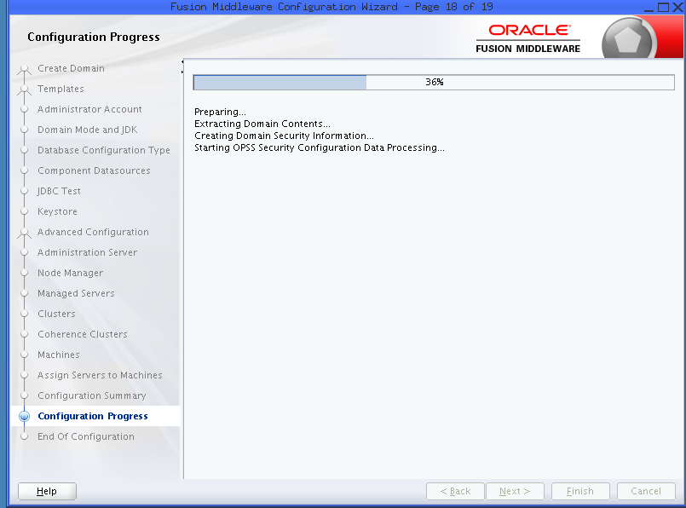

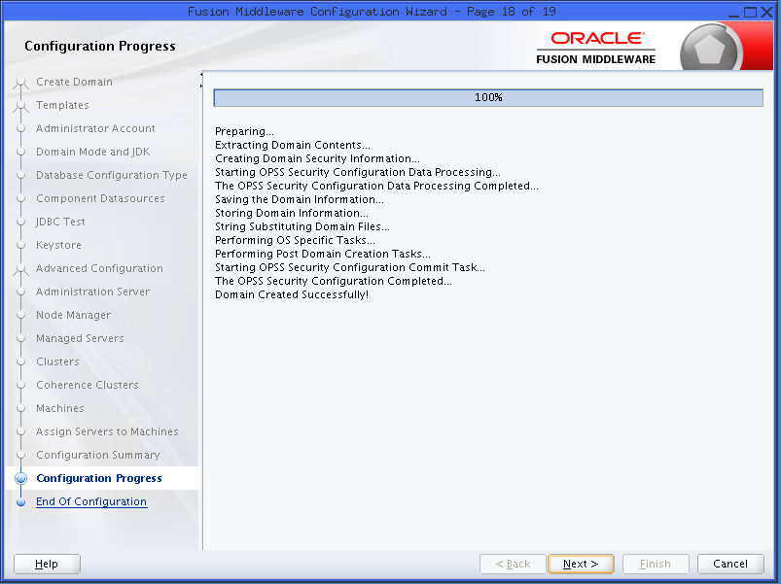

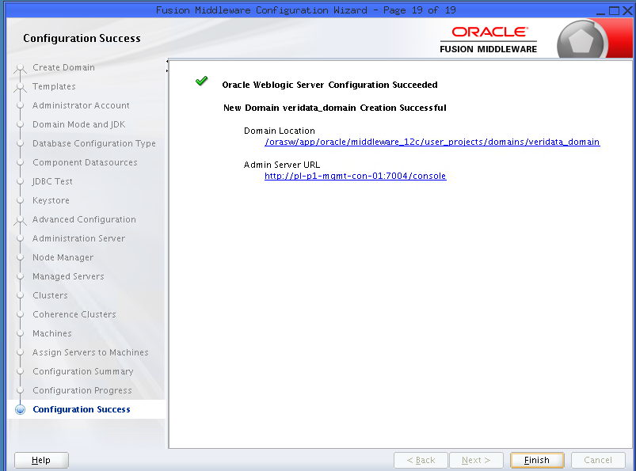

**Start the Admin and Managed Servers**

[oracle@pl-p1-mgmt-con-01 bin]$ **pwd**

/orasw/app/oracle/middleware_12c/user_projects/domains/veridata_domain/veridata/bin

**Start node manager**

nohup ./user_projects/domains/veridata_domain/bin/startNodeManager.sh &

**Start admin server**

**Create boot.properties file**

[oracle@pl-p1-mgmt-con-01 **~]$ cd /orasw/app/oracle/middleware_12c/user_projects/domains/veridata_domain/**

[oracle@pl-p1-mgmt-con-01 oggmon_domain]$ **cd servers/AdminServer**

[oracle@pl-p1-mgmt-con-01 AdminServer]$ **ls**

adr cache data logs sysman tmp

[oracle@pl-p1-mgmt-con-01 AdminServer]$ **mkdir security**

[oracle@pl-p1-mgmt-con-01 AdminServer]$ **cd security/**

[oracle@pl-p1-mgmt-con-01 security]$ **pwd**

/orasw/app/oracle/middleware_12c/user_projects/domains/veridata_domain/servers/AdminServer/security

[oracle@pl-p1-mgmt-con-01 security]$ **vi boot.properties**

[oracle@pl-p1-mgmt-con-01 security]$ **cd /orasw/app/oracle/middleware_12c/user_projects/domains/veridata_domain**

[oracle@pl-p1-mgmt-con-01 oggmon_domain]$ **cd servers/**

[oracle@pl-p1-mgmt-con-01 servers]$ **cd VERIDATA_server1/**

[oracle@pl-p1-mgmt-con-01 MONITORSERVER_server1]$ **mkdir security**

[oracle@pl-p1-mgmt-con-01 MONITORSERVER_server1]$ **cd security/**

[oracle@pl-p1-mgmt-con-01 security]$ **pwd**

/orasw/app/oracle/middleware_12c/user_projects/domains/veridata_domain/servers/VERIDATA_server1/security

[oracle@pl-p1-mgmt-con-01 security]$ **vi boot.properties**

[oracle@pl-p1-mgmt-con-01 security]$ **cat boot.properties**

username=weblogic

password=Tmobile1p

[oracle@pl-p1-mgmt-con-01 bin]$ **pwd**

/orasw/app/oracle/middleware_12c/user_projects/domains/veridata_domain/bin

[oracle@pl-p1-mgmt-con-01 bin]$ **nohup ./startWebLogic.sh &**

[1] 57061

[oracle@pl-p1-mgmt-con-01 bin]$ nohup: ignoring input and appending output to `nohup.out'

[oracle@pl-p1-mgmt-con-01 bin]$ **tail -f nohup.out**

…

..

<Sep 6, 2015 11:20:23 PM PDT> <Notice> <WebLogicServer> <BEA-000329> <Started the WebLogic Server Administration Server "AdminServer" for domain "veridata_domain" running in production mode.>

<Sep 6, 2015 11:20:23 PM PDT> <Notice> <WebLogicServer> <BEA-000360> <The server started in RUNNING mode.>

<Sep 6, 2015 11:20:23 PM PDT> <Notice> <WebLogicServer> <BEA-000365> <Server state changed to RUNNING.>

[oracle@pl-p1-mgmt-con-01 domains]$ **pwd**

/orasw/app/oracle/middleware_12c/user_projects/domains

[oracle@pl-p1-mgmt-con-01 domains]$ **cd veridata_domain/**

[oracle@pl-p1-mgmt-con-01 oggmon_domain]$ **cd bin**

[oracle@pl-p1-mgmt-con-01 bin]$ **nohup ./startManagedWebLogic.sh VERIDATA_server1 http://pl-p1-mgmt-con-01:7004 &**

Once status is changed to RUNNING launch WebLogic Server Console

**Create the VERIDATA_ADMIN user**

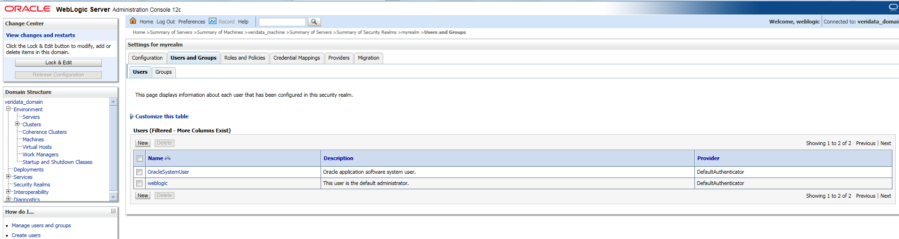

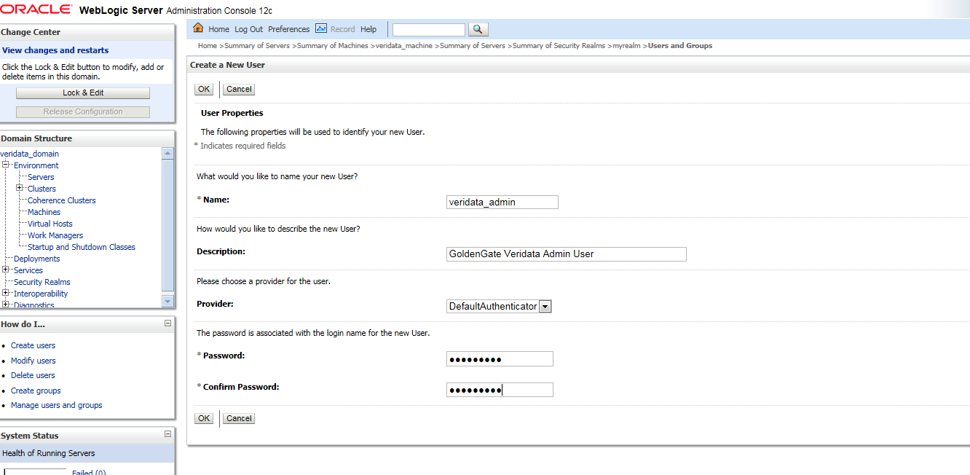

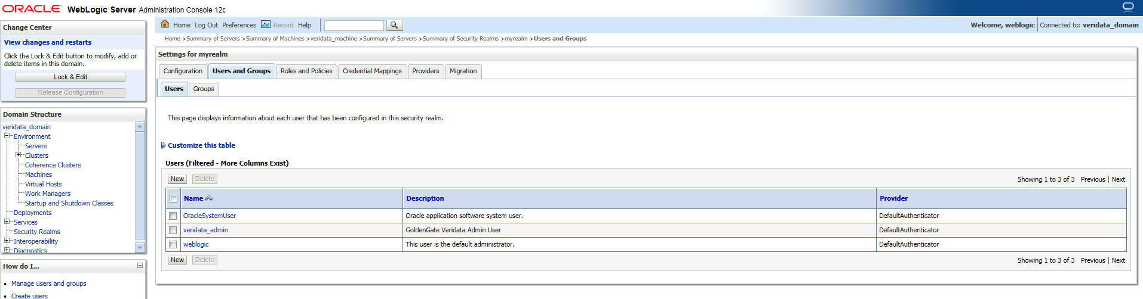

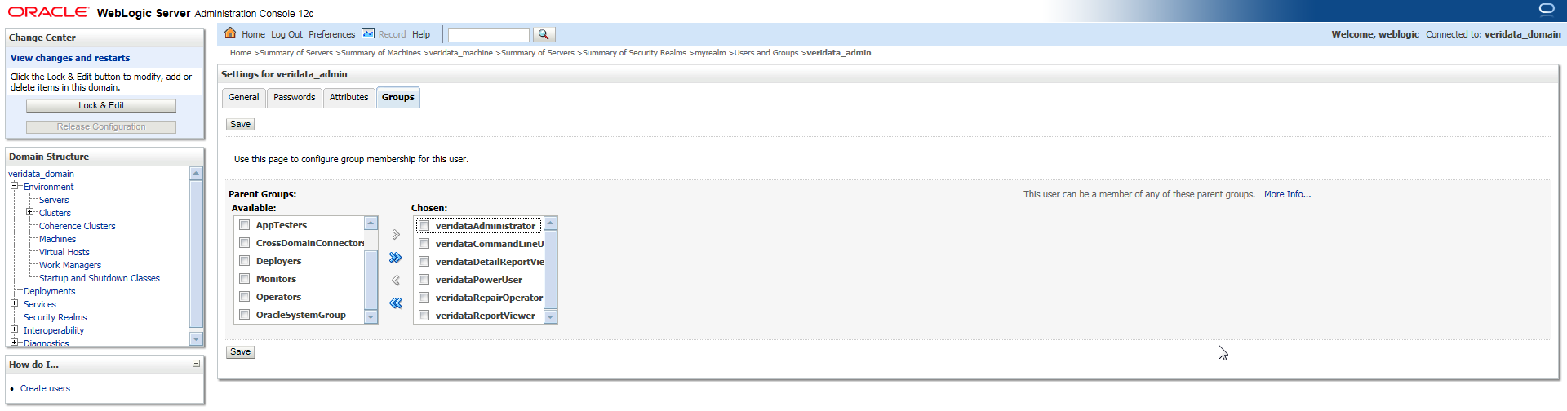

**Click on Save**

**Launch Veridata Web UI**

<http://10.253.8.189:8830>



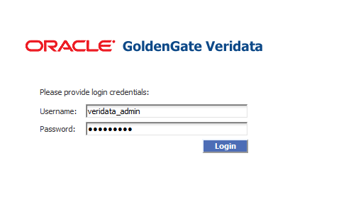

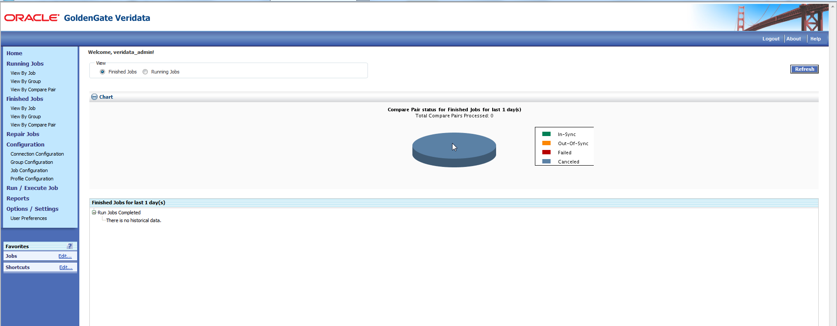

**Deploying and Configuring the Oracle Veridata Agent**

Copy **fmw_12.1.3.0.0_ogg.jar** to target hosts where the agent is going to be installed

Create the directory for Veridata Agent

[oracle@p0017 stage]$ **mkdir -p /orasw/app/oracle/veridata_agent**

[oracle@p0017 ~]$ **java -version**

java version "1.7.0_80"

Java(TM) SE Runtime Environment (build 1.7.0_80-b15)

Java HotSpot(TM) 64-Bit Server VM (build 24.80-b11, mixed mode)

[oracle@p0017 ~]$ **cd /orasw/stage/ggs_121210/**

[oracle@p0017 ggs_121210]$ **java -jar fmw_12.1.3.0.0_ogg.jar**

Launcher log file is /tmp/OraInstall2015-09-06_11-31-31PM/launcher2015-09-06_11-31-31PM.log.

Extracting files.....

Starting Oracle Universal Installer

Checking if CPU speed is above 300 MHz. Actual 2600.000 MHz Passed

Checking monitor: must be configured to display at least 256 colors. Actual 16777216 Passed

Checking swap space: must be greater than 512 MB. Actual 100663292 MB Passed

Checking if this platform requires a 64-bit JVM. Actual 64 Passed (64-bit not required)

Checking temp space: must be greater than 300 MB. Actual 18073 MB Passed

Preparing to launch the Oracle Universal Installer from /tmp/OraInstall2015-09-06_11-31-31PM

Log: /tmp/OraInstall2015-09-06_11-31-31PM/install2015-09-06_11-31-31PM.log

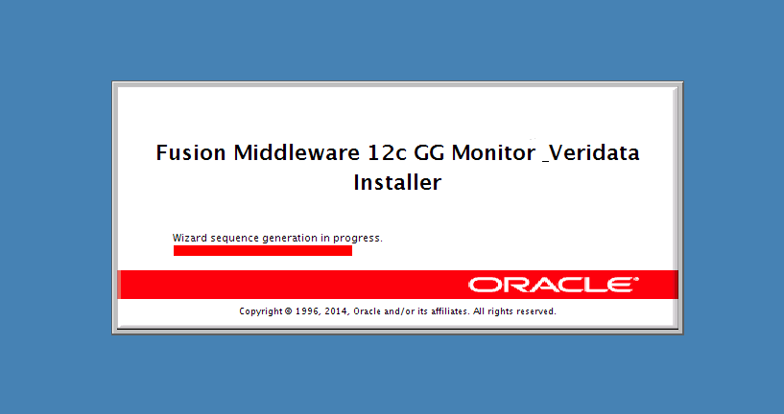

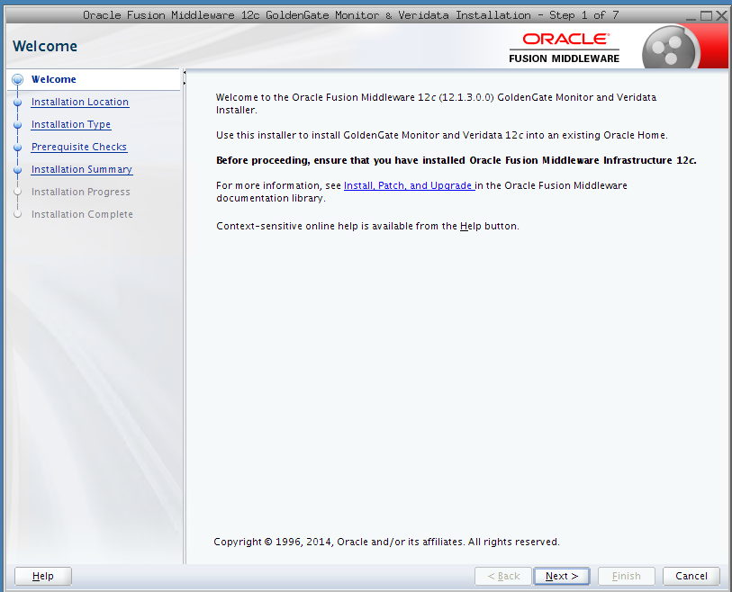

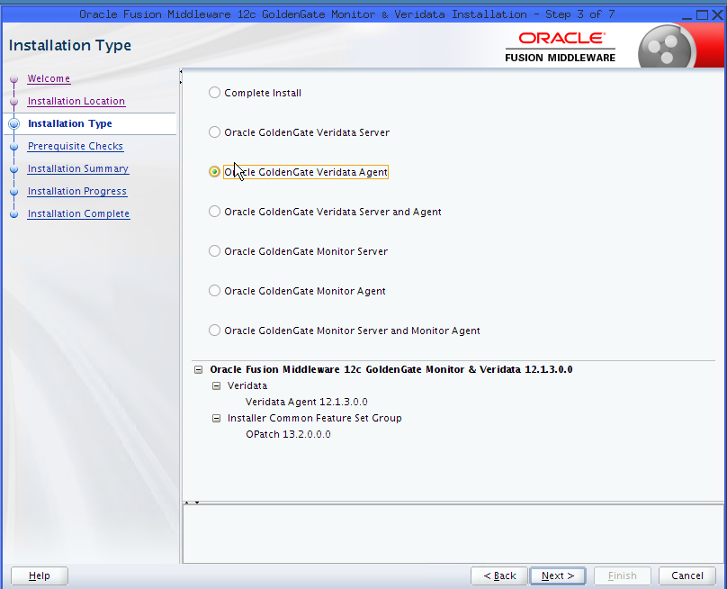

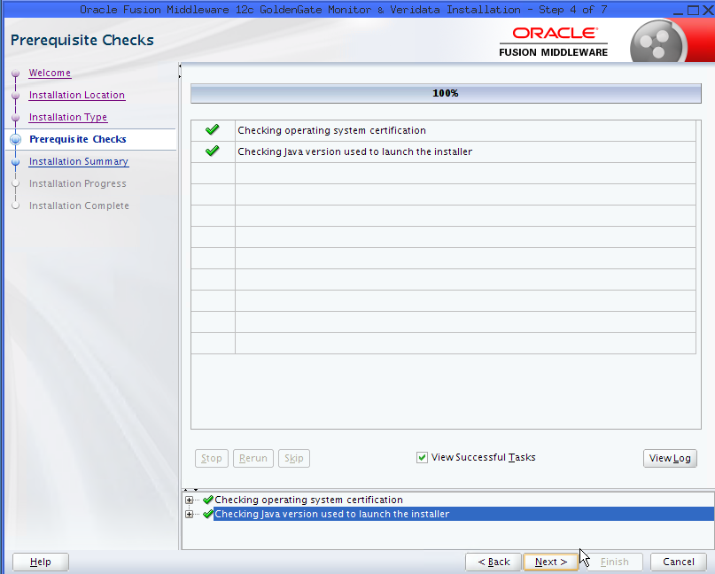

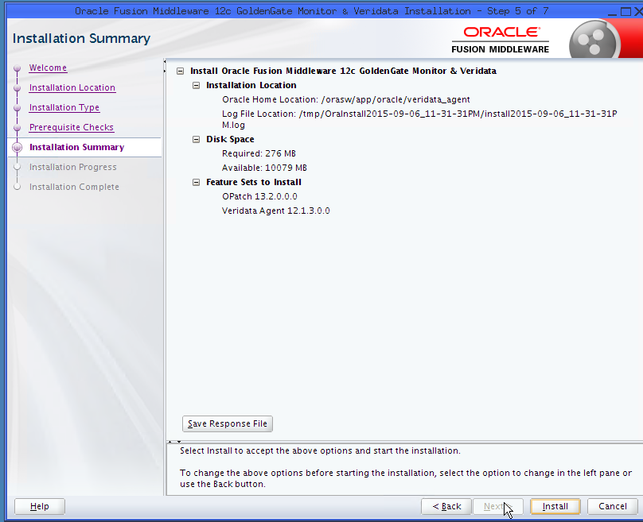

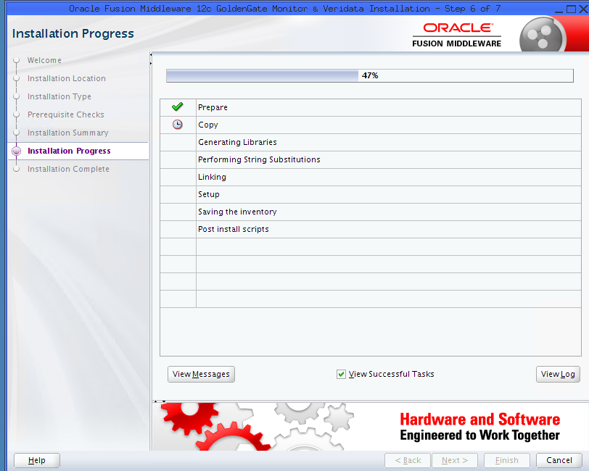

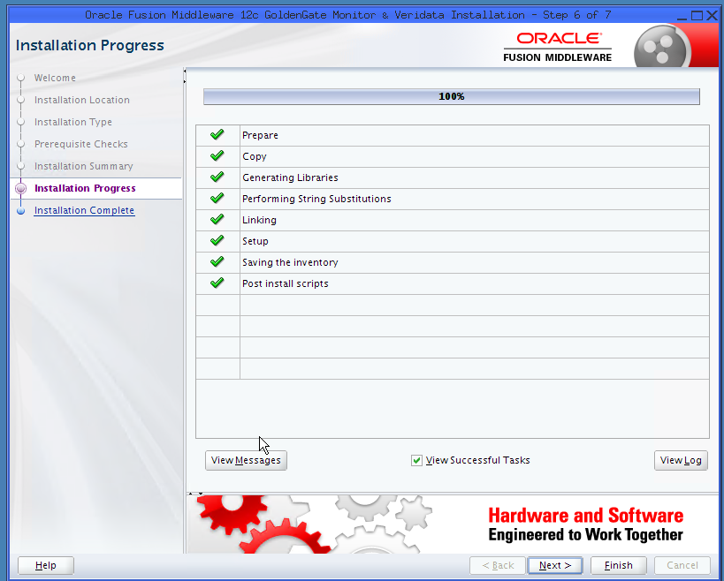



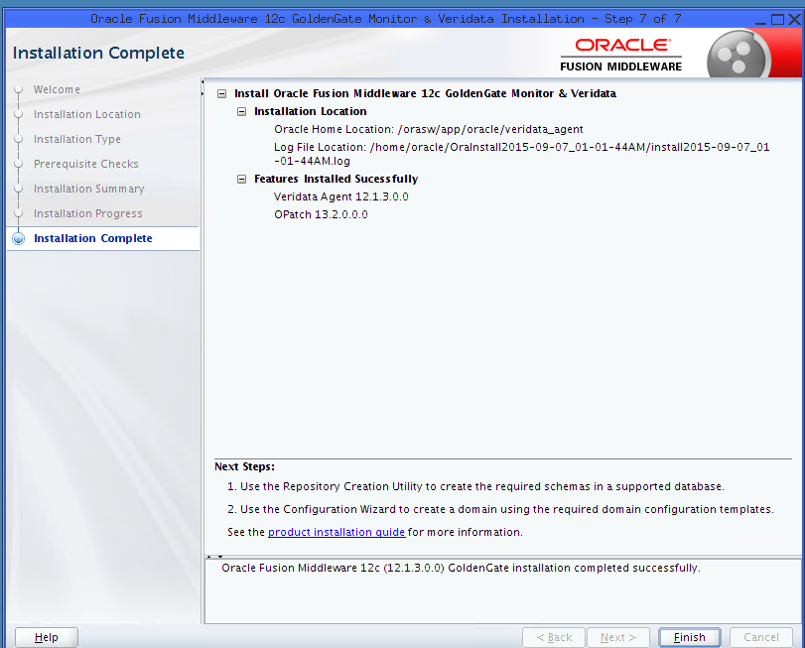

[oracle@p0017 agent]$ **which java**

/usr/bin/java

[oracle@p0017 agent]$ **export JAVA_HOME=/usr**

[oracle@p0017 agent]$ **cd /orasw/app/oracle/veridata_agent/veridata/agent**

[oracle@p0017 agent]$ **./agent_config.sh /orasw/app/oracle/veridata_agent_deploy**

Successfully deployed the agent.

[oracle@p0017 agent]$ **cd /orasw/app/oracle/veridata_agent_deploy**

[oracle@p0017 veridata_agent_deploy]$ **ls**

agent.properties.sample agent.sh config configure_agent_ssl.sh drivers VAOH.sh

pl-p1-bscs-db-01@oracle:bsprd1>**cp agent.properties.sample agent.properties**

pl-p1-bscs-db-01@oracle:bsprd1>**vi agent.properties**

server.port=7850

database.url=jdbc:oracle:thin:@bildbp1-bs-scan:1622/bsprd

server.jdbcDriver=ojdbc7.jar oracle.xdb_12.1.0.jar

pl-p1-bscs-db-01@oracle:bsprd1>**which java**

~/java_1.7/jdk1.7.0_79/bin/java

pl-p1-bscs-db-01@oracle:bsprd1>**echo $JAVA_HOME**

/home/oracle/java_1.7/jdk1.7.0_79

pl-p1-bscs-db-01@oracle:bsprd1>**./agent.sh start**

pl-p1-bscs-db-01@oracle:bsprd1>**cd logs**

/orasw/app/oracle/veridata_agent_deploy/logs

pl-p1-bscs-db-01@oracle:bsprd1>**tail -f veridata-agent.log**

[2015-09-07T04:24:37.635-07:00] [veridata] [NOTIFICATION] [OGGV-60002] [oracle.veridata.agent] [tid: 1] [ecid: 0000KybZFT77y0t5GfCCyf1LvNFp000001,0] Veridata Agent starting on pl-p1-bscs-db-01 port 7850